DEPARTMENT OF

COMPUTERSCIENCE &ENGINEERING

 | Experiment 5.1
Student Name: Pratik Kaushal |  | UID:22BCS10026
Branch: CSE |  | Section:DL-902/A
Semester: 6th |  | DOP: 17-02-2025
Subject: PBLJ |  | Subject Code:22CSH-359

Aim: Write a Java program to calculate the sum of a list of integers using autoboxing and unboxing. Include methods to parse strings into their respective wrapper classes (e.g., Integer.parseInt()).

Objective: Demonstrate autoboxing and unboxing in Java by converting string numbers into Integer objects, storing them in a list, and computing their sum.

Algorithm:

Step 1: Initialize the Program

- Start the program.

- Import ArrayList and List classes.

- Define the AutoboxingExample class.

Step 2: Convert String Array to Integer List

- Define the method parseStringArrayToIntegers(String[] strings).

- Create an empty ArrayList<Integer>.

- Iterate through the string array:

  - Convert each string to an Integer using Integer.parseInt(str). o Add the integer to the list (autoboxing happens here).

- Return the list of integers.

- Define the method calculateSum(List<Integer> numbers).

- Initialize a variable sum to 0.

- Iterate through the list:

  - Extract each integer (unboxing happens here). o Add it to sum.

- Return the total sum.

- Define main(String[] args).

- Create a string array with numeric values.

- Call parseStringArrayToIntegers() to convert it into a list of integers.

- Call calculateSum() to compute the sum.

- Print the result.

Step 5: Terminate the Program

1. End the execution.
DEPARTMENT OF
COMPUTERSCIENCE &ENGINEERING

Code:

import java.util.ArrayList;
import java.util.List;

public class AutoboxingExample {
public static void main(String[] args) {
String[] numberStrings = {"10", "20", "30", "40", "50"};

List<Integer> numbers = parseStringArrayToIntegers(numberStrings);

int sum = calculateSum(numbers);

System.out.println("The sum of the numbers is: " + sum);
}

public static List<Integer> parseStringArrayToIntegers(String[] strings) { List<Integer> integerList = new ArrayList<>();

for (String str : strings) {
integerList.add(Integer.parseInt(str));
}
return integerList;
}

public static int calculateSum(List<Integer> numbers) { int sum = 0;

for (Integer num : numbers) {
sum += num;
}
return sum;
}
}

Output:
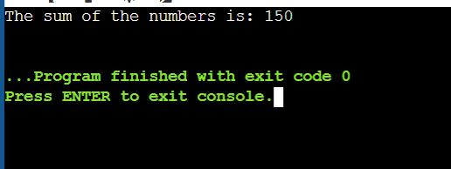

Learning Outcomes:

- Understand the concept of autoboxing and unboxing in Java and how primitive types are automatically converted to their wrapper classes and vice versa.

- Learn how to convert string values into Integer objects using Integer.parseInt() and store them in a list.

- Gain experience in working with ArrayLists to store and manipulate a collection of numbers dynamically.

- Develop proficiency in iterating through collections and performing arithmetic operations like summation.
DEPARTMENT OF
COMPUTERSCIENCE &ENGINEERING

Experiment 5.2

1.Aim: Create a Java program to serialize and deserialize a Student object.

The program should:

- Serialize a Student object (containing id, name, and GPA) and save it to a file.

- Deserialize the object from the file and display the student details.

- Handle FileNotFoundException, IOException, and ClassNotFoundException using exception handling.

2.Objective: The objective is to serialize and deserialize a Student object, store and retrieve its id, name, and GPA from a file, and handle exceptions like FileNotFoundException, IOException, and ClassNotFoundException.

3.Algorithm:

Step 1: Initialize the Program

- Start the program.

- Import the necessary classes (java.io.*).

- Define a Student class implementing Serializable.

- Declare attributes:
- id (int)

  - name (String) o gpa (double)

- Define a constructor to initialize Student objects.

- Override toString() to display student details.

Step 2: Define the Serialization Method

- Create serializeStudent(Student student).

- Use a try-with-resources block to create an ObjectOutputStream: o Open a FileOutputStream to write to student.ser.
o Write the Student object to the file using writeObject().

- Handle exceptions:

  - FileNotFoundException → Print error message. o IOException → Print error message.

- Print a success message if serialization is successful. Step 3: Define the Deserialization Method

- Create deserializeStudent().

- Use a try-with-resources block to create an ObjectInputStream: o Open a FileInputStream to read student.ser.
o Read the Student object using readObject().

- Handle exceptions:

  - FileNotFoundException → Print error message. o IOException → Print error message.
o ClassNotFoundException → Print error message.

- Print the deserialized student details.

- Define main(String[] args).

- Create a Student object with sample data.

- Call serializeStudent() to save the object.

- Call deserializeStudent() to read and display the object.

Step 5: Terminate the Program

1. End execution.
DEPARTMENT OF
COMPUTERSCIENCE &ENGINEERING

4. Implementation Code:
import java.io.*;

class Student implements Serializable {

private static final long serialVersionUID = 1L;

private int id;

private String name;

private double gpa;

public Student(int id, String name, double gpa) { this.id = id;

this.name = name;

this.gpa = gpa;

}

@Override

public String toString() {

return "Student{id=" + id + ", name='" + name + "', gpa=" + gpa + "}";

}

}

public class StudentSerialization {

private static final String FILE_NAME = "student.ser";

public static void main(String[] args) {

Student student = new Student(1, "Anwar", 7.8);

serializeStudent(student);

deserializeStudent();

}

public static void serializeStudent(Student student) {

try (ObjectOutputStream oos = new ObjectOutputStream(new FileOutputStream(FILE_NAME))) {

oos.writeObject(student);

System.out.println("Student object serialized successfully.");

} catch (FileNotFoundException e) { System.err.println("File not found: " + e.getMessage());
} catch (IOException e) {

System.err.println("IOException occurred: " + e.getMessage());

}

}

public static void deserializeStudent() {

try (ObjectInputStream ois = new ObjectInputStream(new FileInputStream(FILE_NAME)))
{

Student student = (Student) ois.readObject(); System.out.println("Deserialized Student: " + student);

} catch (FileNotFoundException e) { System.err.println("File not found: " + e.getMessage());
} catch (IOException e) {

System.err.println("IOException occurred: " + e.getMessage()); } catch (ClassNotFoundException e) {
DEPARTMENT OF
COMPUTERSCIENCE &ENGINEERING

System.err.println("Class not found: " + e.getMessage());

}

}

}

5.Output
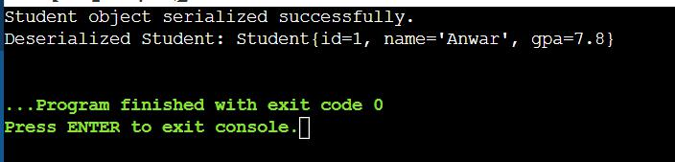

6.Learning Outcomes:
- Understand object serialization and deserialization in Java.

- Learn how to use ObjectOutputStream and ObjectInputStream for file operations.

- Implement exception handling for FileNotFoundException, IOException, and ClassNotFoundException.

- Gain hands-on experience in storing and retrieving objects from a file.

- Develop skills in data persistence and file management using Java.
DEPARTMENT OF
COMPUTERSCIENCE &ENGINEERING

Experiment 5.3

- Aim: Create a menu-based Java application with the following options.

1.Add an Employee

  - Display All

  - Exit If option 1 is selected, the application should gather details of the employee like employee name, employee id, designation and salary and store it in a file. If option 2 is selected, the application should display all the employee details. If option 3 is selected the application should exit.

- Objective: The objective is to develop a menu-based Java application that allows users to add employee details, store them in a file, and display all stored employee records, with an option to exit the program.

- Algorithm:

- Start the program.

- Import java.util.* and java.util.concurrent.* for thread handling.

- Define a class TicketBookingSystem with:

- A List<Boolean> representing seat availability (true for available, false for booked).

- A synchronized method bookSeat(int seatNumber, String passengerName) to ensure thread safety.

1. Define bookSeat(int seatNumber, String passengerName):

- If the seat is available (true), mark it as booked (false). o Print confirmation: "Seat X booked successfully by Y". o If already booked, print: "Seat X is already booked."

1. Create a class PassengerThread extending Thread:

- Store passenger name, seat number, and booking system reference. o Implement run() method to call bookSeat().

- Create VIP and Regular passenger threads.

- Set higher priority for VIP passengers using setPriority(Thread.MAX_PRIORITY).

- Set default priority for regular passengers.

- In main(), create an instance of TicketBookingSystem.

- Accept number of seats and bookings from the user.

- Create multiple PassengerThread instances for VIP and regular passengers.

- Start all threads using start().

- Use the synchronized keyword in bookSeat() to ensure only one thread accesses it at a time.

- Ensure thread execution order by assigning higher priority to VIP threads.

- After all threads finish execution, display the list of booked seats.

- End the program with a message: "All bookings completed successfully."

4.Implementation Code:

i import java.io.*;

import java.util.*;

class Employee implements Serializable {
DEPARTMENT OF
COMPUTERSCIENCE &ENGINEERING

private static final long serialVersionUID = 1L;

private int id;

private String name;

private String designation;

private double salary;

public Employee(int id, String name, String designation, double salary) { this.id = id;

this.name = name;

this.designation = designation;

this.salary = salary;

}

@Override

public String toString() {

return "Employee ID: " + id + ", Name: " + name + ", Designation: " + designation
+ ", Salary: " + salary;

}

}

public class EmployeeManagementSystem {

private static final String FILE_NAME = "employees.ser"; private static List<Employee> employees = new ArrayList<>();

public static void addEmployee() {

Scanner scanner = new Scanner(System.in);

System.out.print("Enter Employee ID: ");

int id = scanner.nextInt();

scanner.nextLine();

System.out.print("Enter Employee Name: ");

String name = scanner.nextLine();

System.out.print("Enter Designation: ");

String designation = scanner.nextLine();

System.out.print("Enter Salary: ");

double salary = scanner.nextDouble();

Employee employee = new Employee(id, name, designation, salary);

employees.add(employee);

saveEmployees();

System.out.println("Employee added successfully!");

}

public static void displayAllEmployees() {

loadEmployees();

if (employees.isEmpty()) {

System.out.println("No employees found.");

} else {

for (Employee employee : employees) {

System.out.println(employee);

}

}

}
DEPARTMENT OF
COMPUTERSCIENCE &ENGINEERING

private static void saveEmployees() {

try (ObjectOutputStream oos = new ObjectOutputStream(new FileOutputStream(FILE_NAME))) {

oos.writeObject(employees);

} catch (IOException e) {

System.err.println("Error saving employees: " + e.getMessage());

}

}

@SuppressWarnings("unchecked")

private static void loadEmployees() {

try (ObjectInputStream ois = new ObjectInputStream(new FileInputStream(FILE_NAME))) {

employees = (List<Employee>) ois.readObject();

} catch (FileNotFoundException e) { employees = new ArrayList<>();
} catch (IOException | ClassNotFoundException e) {

System.err.println("Error loading employees: " + e.getMessage());

}

}

public static void main(String[] args) {

Scanner scanner = new Scanner(System.in);

while (true) {

System.out.println("\nEmployee Management System"); System.out.println("1. Add an Employee"); System.out.println("2. Display All Employees"); System.out.println("3. Exit"); System.out.print("Enter your choice: "); int choice = scanner.nextInt();

scanner.nextLine();

switch (choice) {

case 1:

addEmployee();

break;

case 2:

displayAllEmployees();

break;

case 3:

System.out.println("Exiting...");

return;

default:

System.out.println("Invalid choice! Please try again.");

}

}

}

}
DEPARTMENT OF
COMPUTERSCIENCE &ENGINEERING

5. Output:
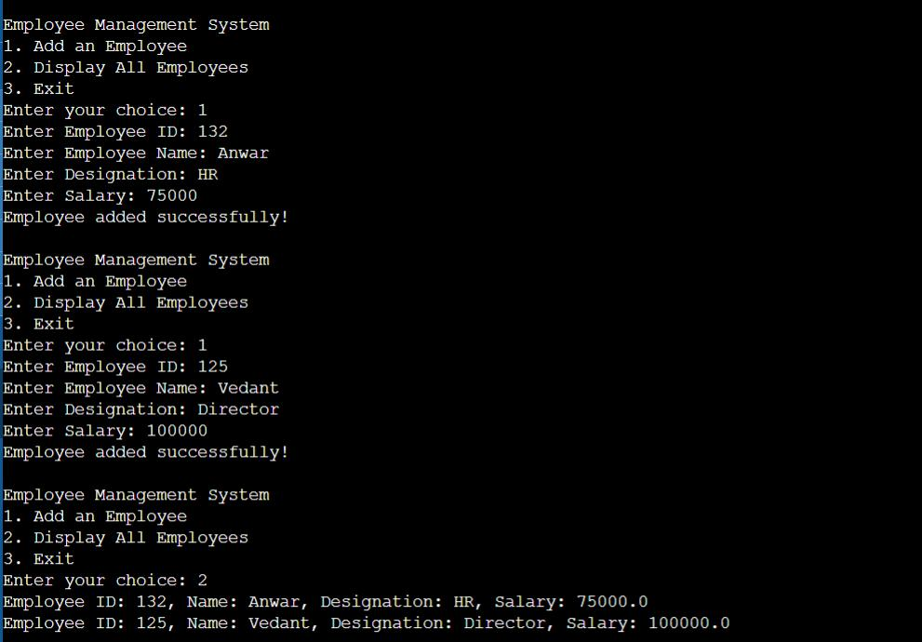

6. Learning Outcomes:
- Understand file handling and serialization in Java to store and retrieve objects persistently.

- Learn how to implement a menu-driven console application using loops and conditional statements.

- Gain experience in object-oriented programming (OOP) by defining and managing Employee objects.

- Practice exception handling to manage file-related errors like FileNotFoundException and IOException.

- Develop skills in list manipulation and user input handling using ArrayList and Scanner.

